IMPORTANT - ALL SITE INDUCTION INFORMATION BELOW MUST BE READ BY ANYONE ENTERING THE HALLS DURING BUILD UP OR BREAKDOWN. Access to the halls may be refused to any person who is unable to confirm that they have seen and understood this information.
SITE INDUCTION INFORMATION

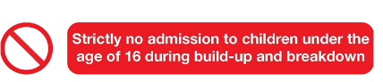
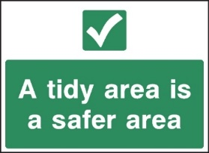
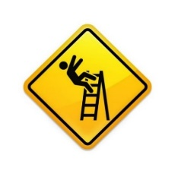
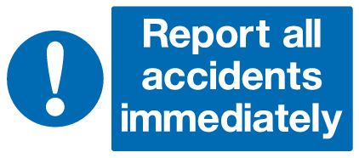
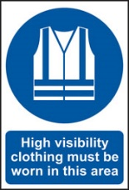
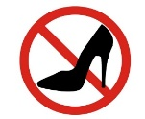
HI-VIS MUST BE WORN IN THE LOADING AREA
Health and safety is everyone’s responsibility and works being carried out should comply with the rules and regulations set out in the exhibitor manual and the venue external contractors terms and conditions

Knowing and sharing – you must ensure that everyone coming onsite to work on your project and their teams fully understand this induction information, as well as the Stand Build, Risk Assessment, Method Statement and Construction Phase Plan.
Consider those working around you – it is vital that you plan and are prepared to work in a way that considers other work going on in the hall so that your actions do not endanger others.

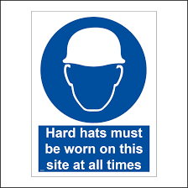

BUILD UP | HALL OPEN | ACCESS FOR
Tuesday 3rd October | 08:00 – 22:00 | Space Only exhibitor and contractor access
 | 15:00 – 22:00 | Shell scheme exhibitor access
 | 22:00 | Hall closes
OPEN | HALL OPEN | EXHIBITION | CONFERENCE
Wednesday 4th October | 08:00 – 18:00 | 09:00 – 18:00 | 08:50 – 18:00
Thursday 5th October | 08:00 – 17:00 | 09:00 – 17:00 | 08:50 – 16:30
BREAKDOWN | HALL OPEN | HALL CLOSED
Thursday 5th October | 17:00 – 19:00 | Shell scheme exhibitors must clear
 | 17:00 – 23:00 | Space Only stands removal
 | 23:00 | Hall closes

VEHICLES AND UNLOADING
- FOLLOW INSTRUCTIONS from Traffic staff and park in designated or instructed areas only.

- VEHICLE MOVEMENT – be aware of forklift truck movement and all other vehicle movement at all times. Vehicles have priority in loading areas, and anyone entering these areas should be aware of this.

EMERGENCY INFORMATION
- Listen to tannoy messages and follow these instructions at all times
- Please use the following numbers to alert the emergency services:

Evacuation Procedure: Leave the building by the nearest exit and you will be directed to your nearest assembly point.
Measures and reactions to immediate, life threatening, emergencies (e.g. evacuation due to fire or terrorist attack) take precedence over any COVID-19 controls. Such measures are not applicable where there is an immediate threat to life.

CONTACT DETAILS:
If you need assistance during your time at The Athenee, Bangkok, you can speak to the nearest member of the security staff, or the Organisers Office, who will be happy to assist you.

EMERGENCY NUMBERS IN ASIA:
All Emergencies: 911 or 191
Police: 191
Ambulance: 1669
Fire department: 199

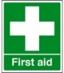
The Organisers Office is located outside the Crystal Hall in the foyer area. Visit for site information and H&S queries.
There are water fountains located in the exhibition hall during build and breakdown
PICO are located in the hall for any electrical, shell build or AV/furniture/carpet queries
WELFARE LOCATIONS

If you require medical assistance please report it to the nearest security person or organiser. First aiders can be reached via the hotel lobby or call + 66 2650 8700

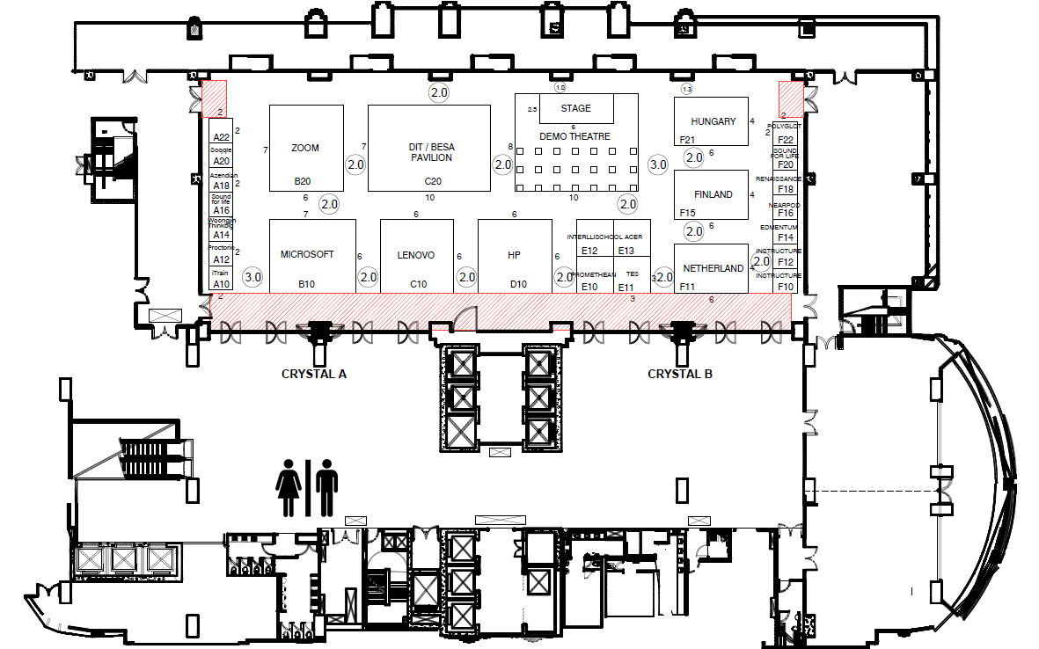
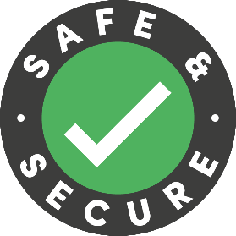
COVID-19 SITE SAFETY

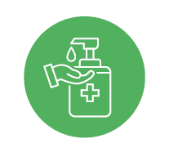
Please regularly wash or sanitise your hands

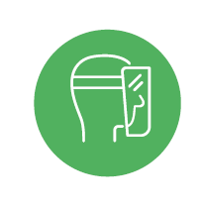
We are a mask friendly event and encourage face coverings to be worn during close contact working or in crowded spaces. However, if any of your construction activities are made dangerous by wearing a mask please do not wear one.
Face masks are mandatory when taking food or beverage from buffet areas

Contractor service desks are located at the front of each of the hall entrances.

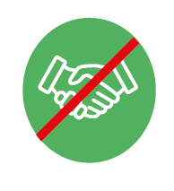
Avoid physical contact where possible.
Ensure you are thoroughly cleaning any areas that you are working in.

